|  |
| --- |
| Oklahoma State University |
| IR Research |
| Aaron Humphries |
|  |
|  |
| **10/12/2011** |

|  |
| --- |
|  |

# Objective

This research is to help set up an infrared transmitter device, an infrared receiver device, and handle all infrared packet protocols within the microcontroller.

The IR transmitter will consist of an IR LED connected to an output pin of the microcontroller; this will be used to transmit IR data packet a.k.a. an attack to an enemy IR receiver.

The IR receiver will be pulled low anytime a modulated IR packet has been detected; the receiver is connected to an input pin/interrupt pin on the microcontroller in order to communicate the packet data received through to the HIU.

Within the microcontroller the IR handler will decode any received IR packets and communicate the data to the HIU. The microcontroller will also encode the IR packets to be transmitted and then communicate that to the IR LED. The packet data are explained more in “Timing and Packet Structure” section.

# Block Diagram (IR Section)



# IR Hardware Specifications

* ALL IR Tx/Rx devices must operate at 940nm wavelength
* ALL IR signals will be modulated at 56kHz
* IR Tx:
  + TSAL6200 - <http://www.vishay.com/docs/81010/tsal6200.pdf>
    - Radiant intensity: min = 40 | typ = 60 | max= 200 (mW/sr)
  + TSAL6100 - <http://www.vishay.com/docs/81009/tsal6100.pdf>
    - Radiant intensity: min = 80 | typ = 130 | max= 400 (mW/sr)
* IR Rx:
  + TSOP34856 - <http://www.vishay.com/docs/81732/tsop348.pdf>
    - Eemin = 0.1(mW/ $m^{2}$)(typ) | 0.25(mW/ $m^{2}$)(Max)
* De-multiplexer
  + 74HC238 - <http://www.nxp.com/documents/data_sheet/74HC_HCT238.pdf>
* The maximum possible transmission distance of an IR system depends on various parameters but is mainly conditional on the radiant intensity of the emitter(Ie) and sensitivity of the receiver(Eemin).

$d_{\max{= \sqrt{\frac{I_{e}}{E_{emin}}}}}$

# Timing and Packet Structure

* IR data signals will be preceded by a “start-of-data” marker and succeeded by “end-of-data” [1]
  + S-o-D - 4ms ON signal followed by 4ms OFF signal
    - ON signal defined as 56kHz square wave
  + E-o-D – 0.5ms ON
* Logic 0 – 0.5ms ON, 1ms OFF [1]
* Logic 1 – 0.5ms ON, 2ms OFF [1]
* IR data packet (non-variable length) contains 24bits: 12bits of data + 12bits of inverted (for error correction) [1]
  + 12bit packet is broken down into a 4bit ‘A’ section and 8bit ‘B’ section
  + LSB is transmitted first and received first
  + 12bits of arbitrary values
* IR Rx will use an external interrupt pin to signal an IR packet has been received
  + The microcontroller will filter any noise and ensure a proper signal has been received

# MultiSim Schematic

* IR Tx (see Figure 3 (IR Tx)) – schematic [2]
  + Prototype – to test IR transmitter
    - LM555 Timer, (R3) variable resistor to pulse IR LED at 56kHz
    - Output see Figure 9 (IR Tx Output)
  + Actual Implementation
    - Using PIC18f4520 PWM to pulse the IR at 56kHZ
    - Using PIC18f4520 to encode proper damage within the packet
    - A mux and an option of resistors to limit voltage to IR LED
      * The resistors should limit power delivered to the IR LED and result in limiting the distance of the IR packet, i.e. 5-25 feet.
* IR Rx (see Figure 4 (IR Rx)) – schematic [3], [4]
  + Prototype – To test transmission of IR modulated signal
    - Test LED used to indicate when receiver detects a modulated IR signal
  + Actual Implementation
    - Using PIC18f4520 to filter out any noise and check if correct modulated signal has been received
  + Also using PIC18f4520 for decoding IR packet

# Transmission Distance

* Using a de-multiplexer and a selection of resistors, the current to the IR LED will be limited. This will result in a lowered radiant intensity from the IR and thus result in a smaller transmission distance Figure 6 (IR Tx Actual Implementation).
  + De-Multiplexer
    - [SN74AHCT139NE4](http://www.mouser.com/ProductDetail/Texas-Instruments/SN74AHCT139NE4/?qs=sGAEpiMZZMtxONTBFIcRfrHRktOy0PMdwRFHsbojVpQ%3d) - <http://www.ti.com/lit/ds/symlink/sn74ahct139.pdf>
    - 74HC238 - <http://www.nxp.com/documents/data_sheet/74HC_HCT238.pdf>
  + Resistor values will be determined in prototyping
  + VDD input to the de-multiplexer will be the PWM signal from the pic
  + Selection bits will come from 2 output pins from the PIC
  + Binary encoding will be used for selector bits
  + Increasing the resistance limits the current see(Figure 6,7,8)
* As the forward current of the IR increases, the radiant intensity increases linearly.
* In order to supply enough current to the LED, a MOSFET will be added as a buffer from the de-multiplexer to the LED
  + This should amplify the current output from the de-multiplexer while ensuring current limits as not to damage the LED
  + 1.8-5.5V supply voltage
  + 200 and 400mA current limit options
  + http://www.fairchildsemi.com/ds/FP/FPF2106.pdf

# Alternatives

* Use a digital potentiometer to limit IR transmission distance relative to the force of a throw.
  + Rejection reasons: overly complicated to implement both in hardware, it would require too many pins from the PIC to do a simple selection process.
* Using multiple IR LEDs from low to high power to transmit at selected distances.
  + Reasons: If the resistor implementation does not achieve proper modulation and distance transmission, using multiple IR LEDs rated at different intensities should provide the necessary distance transmissions.
  + However, this alternative would cost circuit board space.
  + To choose which IR LED to use, we would implement a mux and a selector bit from the PIC to choose the correct LED.
* Using a transistor to limit the current to the IR LED
  + Connecting the gate of the transistor to a PWM pin on the pic to control the amount of voltage through the transistor from the PIC to the LED.
    - PWM1 would be connected to the Gate of the transistor
      * PWM1 would use the duty cycle to control the flow
    - PWN2 would connect to the Drain of the transistor
      * PWM2 would be the 56kHz signal
    - Source would be connected to LED
* Using a high output current amplifier such as the AD8009
  + These amplifiers provide low distortion current amplification
  + Works well as a pulse amplifier
  + Can provide up to 175mA
  + Operates at +-5V, 14mA supply current
  + Will work with de-multiplexer
  + Power dissipation 0.75W
  + http://www.analog.com/static/imported-files/data_sheets/AD8009.pdf
* Using a high output differential drive Op-Amp
  + Supply: 2.7-5.5V, 1.4mA
  + RMS output current 110mA
  + High power consumption 1.23W
  + <http://www.ti.com/lit/ds/symlink/tlv4120.pdf>
* Using a high speed Mux/Demux to output high current
  + ADG3257 quad 2:1 Demux
  + 3.3/5V single supply operation
  + DC output max 100mA
  + http://www.analog.com/static/imported-files/data_sheets/ADG3257.pdf

# Pseudo Code

* IR Tx Flowchart



Figure (IR Tx Flowchart)

* IR Rx Flowchart



Figure (IR Rx Flowchart)

# Bibliography

|  |  |
| --- | --- |
| [1] | ECEN4013, "Communication (IPLoS) Protocol," Stillwater, 2011. |
| [2] | D. Bodnar, "Pulsed Infrared Sensors," 09 April 2005. [Online]. Available: http://www.trainelectronics.com/artcles/PulsedIR/index.htm. [Accessed 11 October 2011]. |
| [3] | Ladyada, "IR Detector," 28 Feburary 2011. [Online]. Available: http://www.ladyada.net/learn/sensors/ir.html. [Accessed 11 October 2011]. |
| [4] | Vishay, "TSOP34856," 11 March 2011. [Online]. Available: http://www.vishay.com/docs/81732/tsop348.pdf. [Accessed 11 October 2011]. |

# Appendix

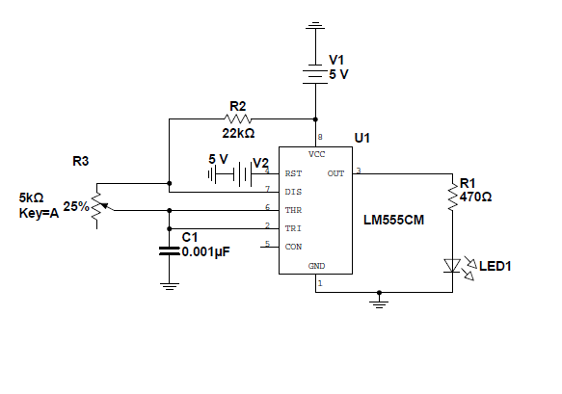

Figure (IR Tx Test Circuit)

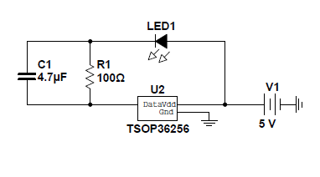

Figure 4 (IR Rx Test Circuit)

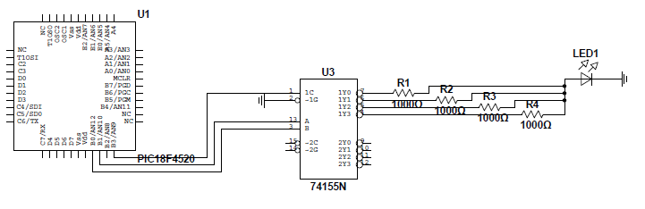

Figure 5 (IR Tx Actual Implementation)

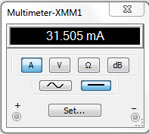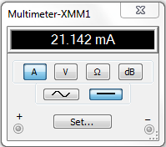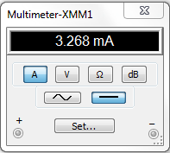

Figure 6 (R1 = 100ohms) Figure 7 (R2 = 150ohms) Figure 8 (R3 = 1000ohms)

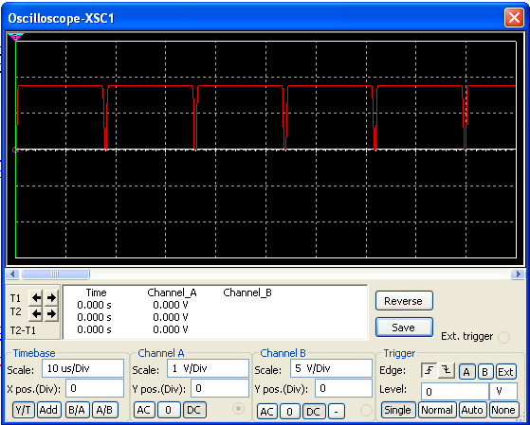

Figure 9 (IR Tx Output)